1. Choose 3 categories to scrape:

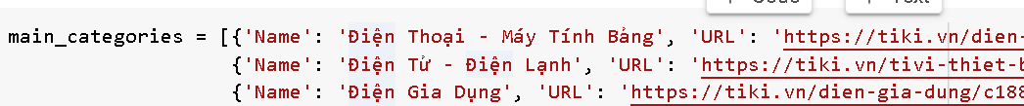

1. Get all categories in 3 main_categories, we have 180 categories

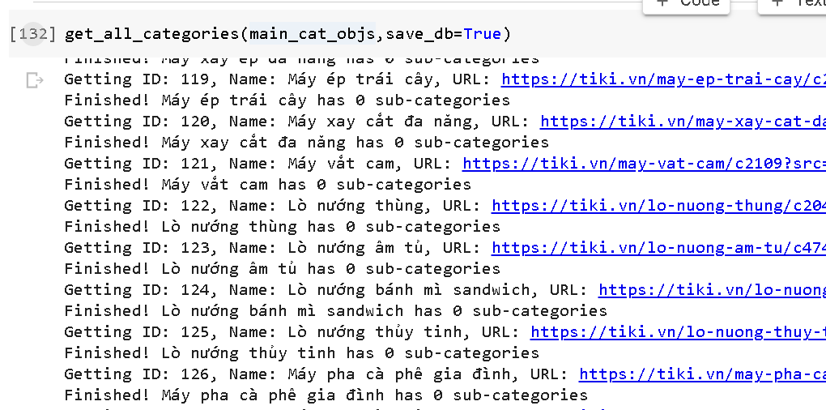

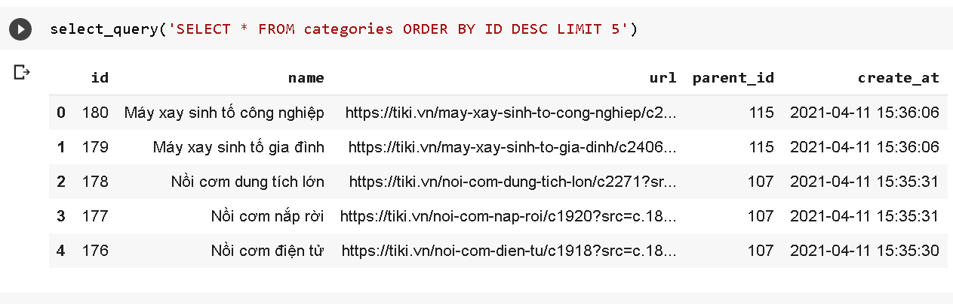

1. Find **lowest_sub_categories**

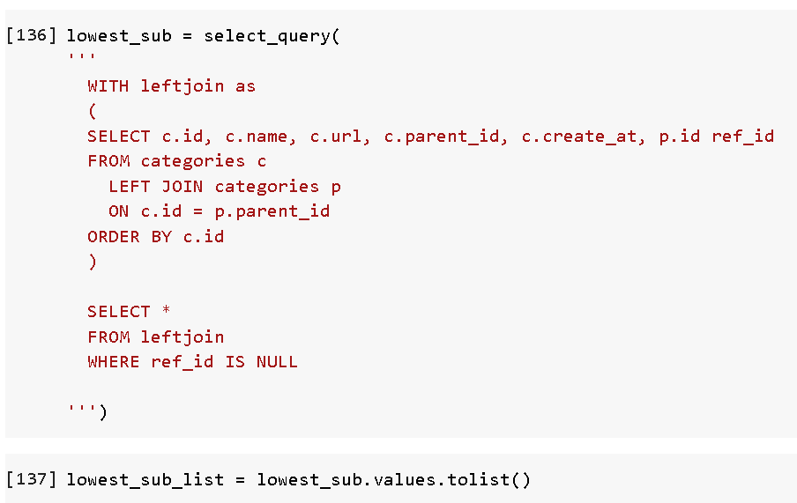

1. Build tupple list **base_urls** to prepare all urls to scrape products

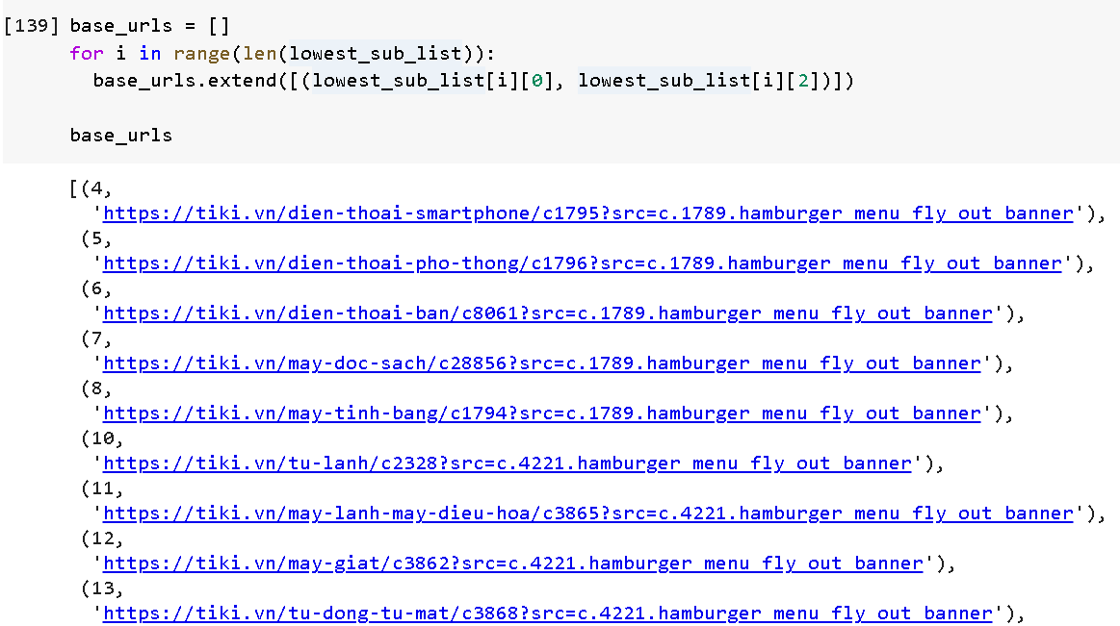

1. Function: **def extract_tiki_info(parent_id, url)** we add key **parend_id** to product dictionary

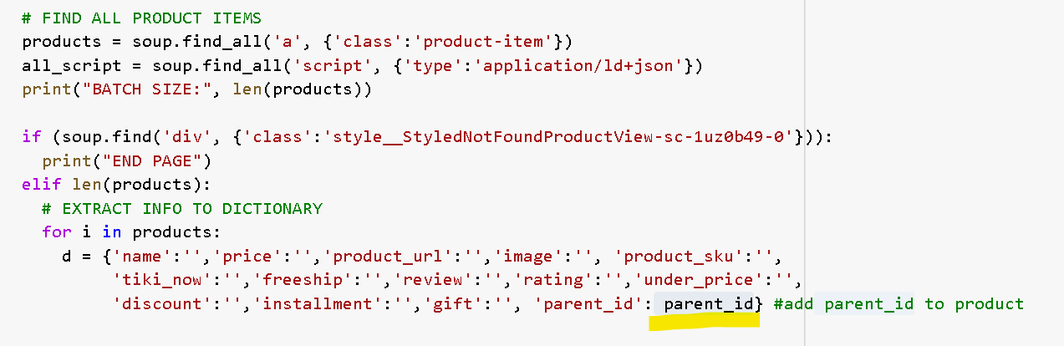

1. Edit **function def scrape_tiki_team(base_urls)**

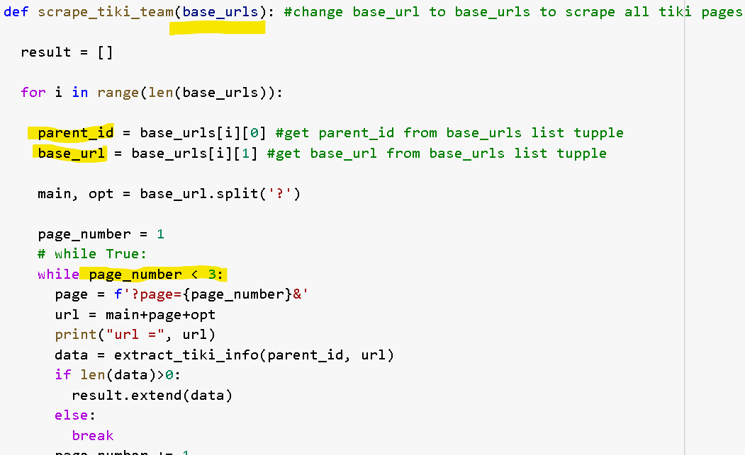

1. Enjoy many cups of coffee with tiki web scraping

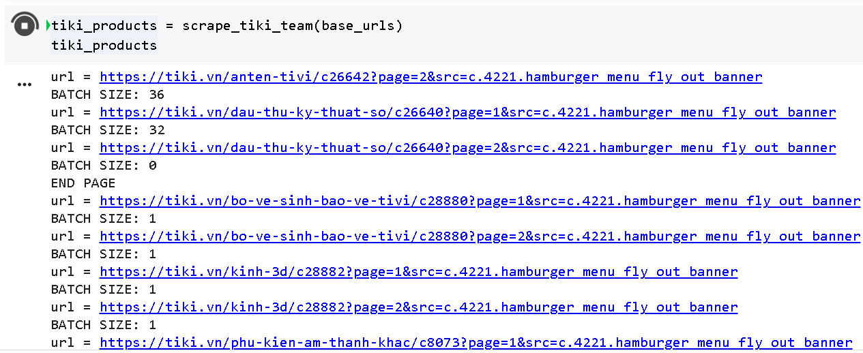

1. A FEW MOMENT LATER… BOOM! We have **11032 products**

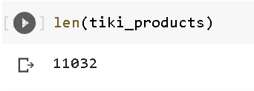

1. Create **Products** table:

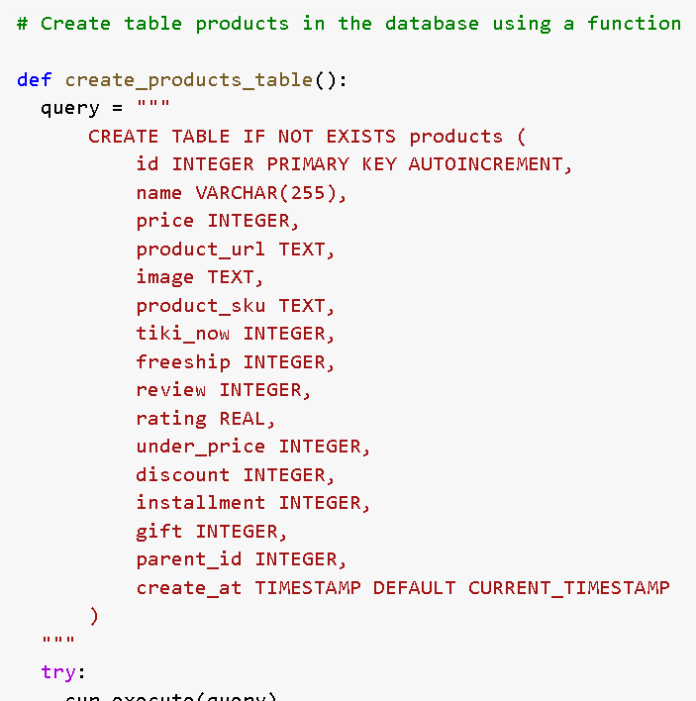

1. Create **Class Product** to store product attributes, use **product_sku** as ID

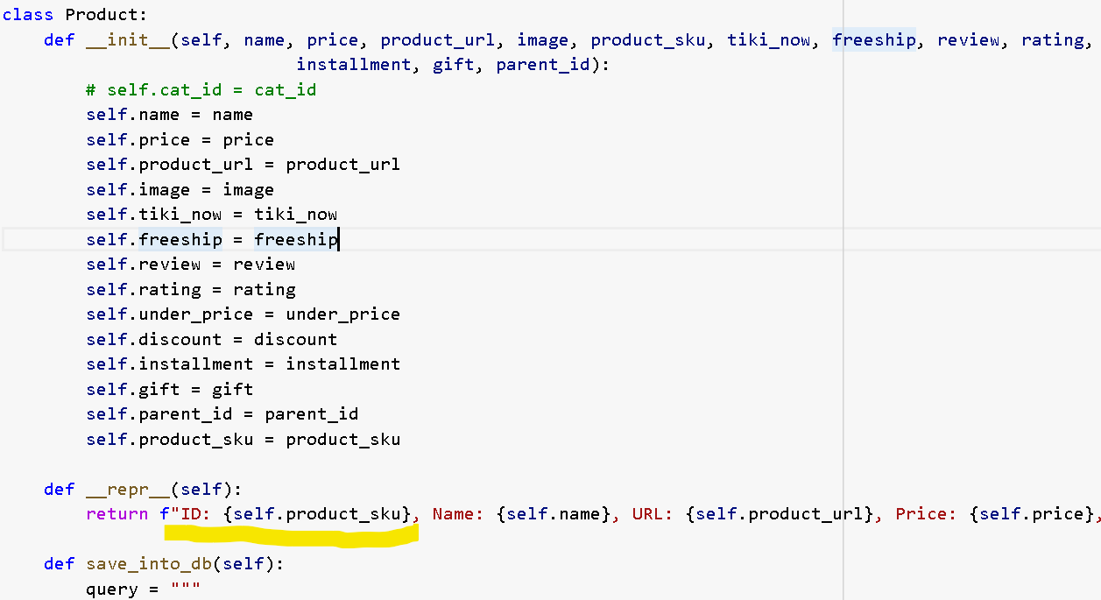

1. Create **PRODUCT_SET** and function **def can_add_to_cat_set_product(product_sku,save=False)** check product imported to database or not

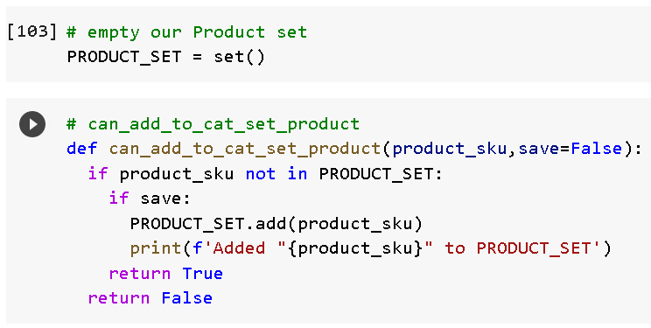

1. Create **function def get_product(tiki_products,save_db=False)** to import data row by row to database

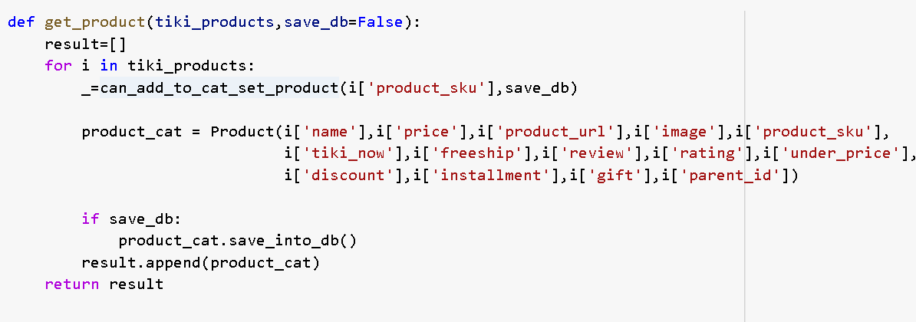

1. Import to database… wait and wait and more coffee

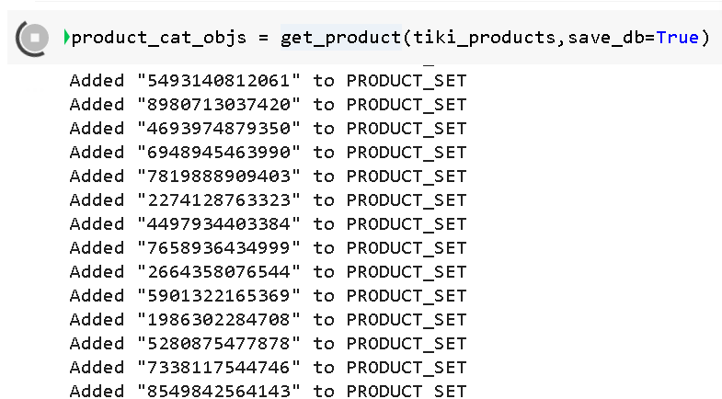

1. Now is MID NIGHT, I NEED SLEEP!
2. WHAT THE HELL IS GOING ON!!!! SOMETHING HAPPENNED!

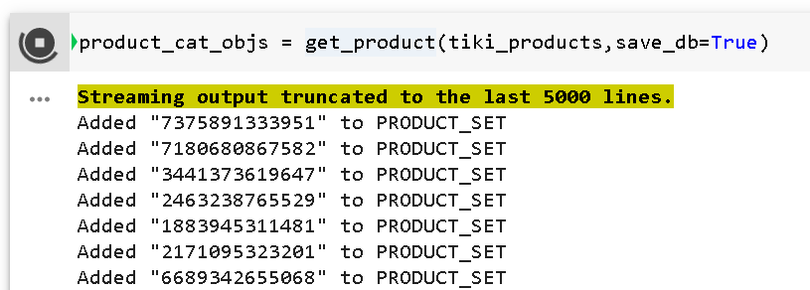

Actually we have another solution to do bulk import data to SQL in short time but we want to follow the project structure to check duplication and import data row by row and get real **NIGHTMARE.**

Wow, after 32m, all products imported to database

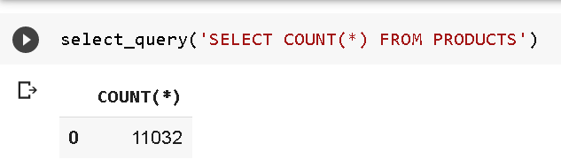

1. What is the most expensive product for all category?

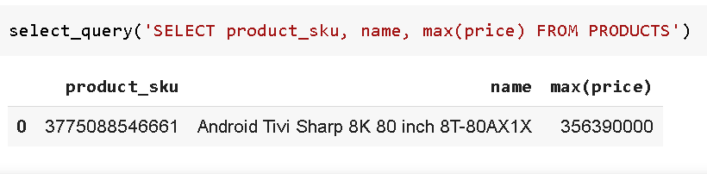

1. What is the most expensive item for each category?

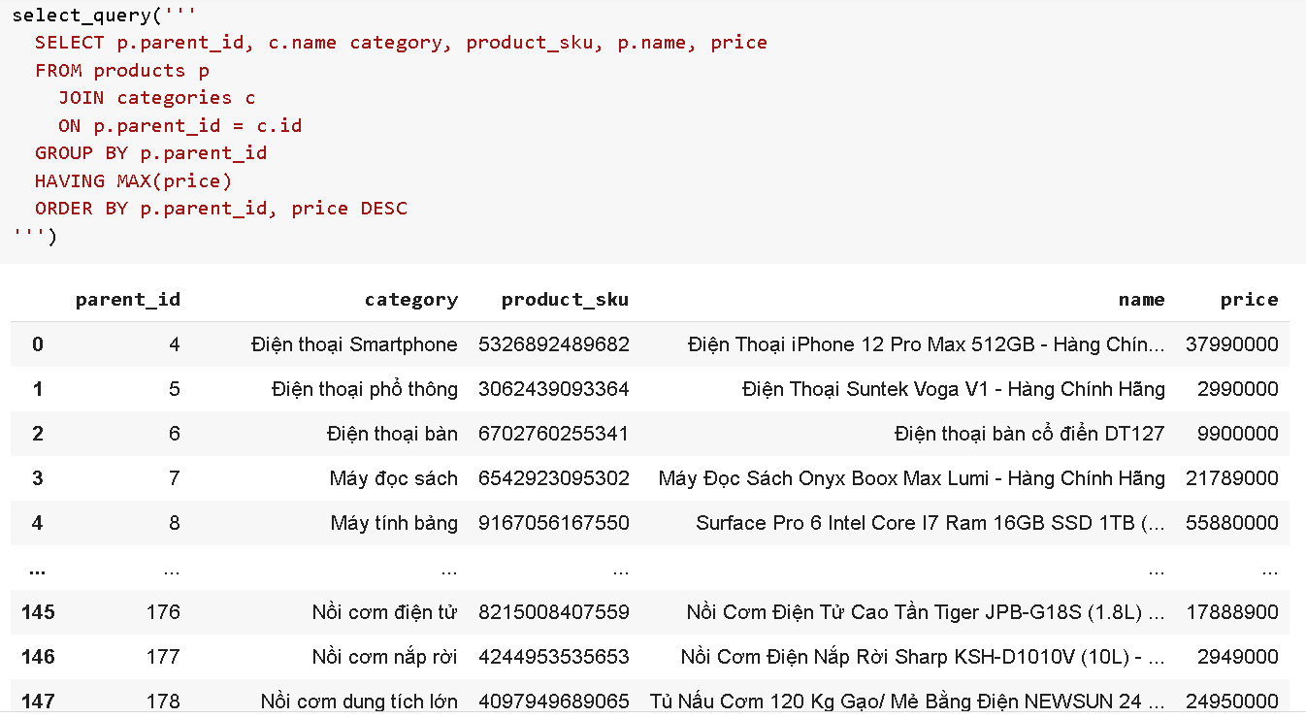

1. Which category contains the most items?

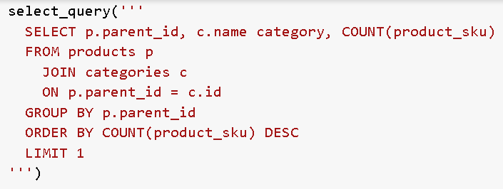

1. Which category/product has the highest reviews or ratings ...?

CHƯA LÀM, BUỒN NGỦ QUÁ ROÀI

1. This week project we learned read code, understand code, copy, paste and edit code. Chrome addon to keep Colab run but sometimes Colab give us a warning board to verify us is human or bot.
2. An error when we forgot some letter when coding

